1. Counting Elements

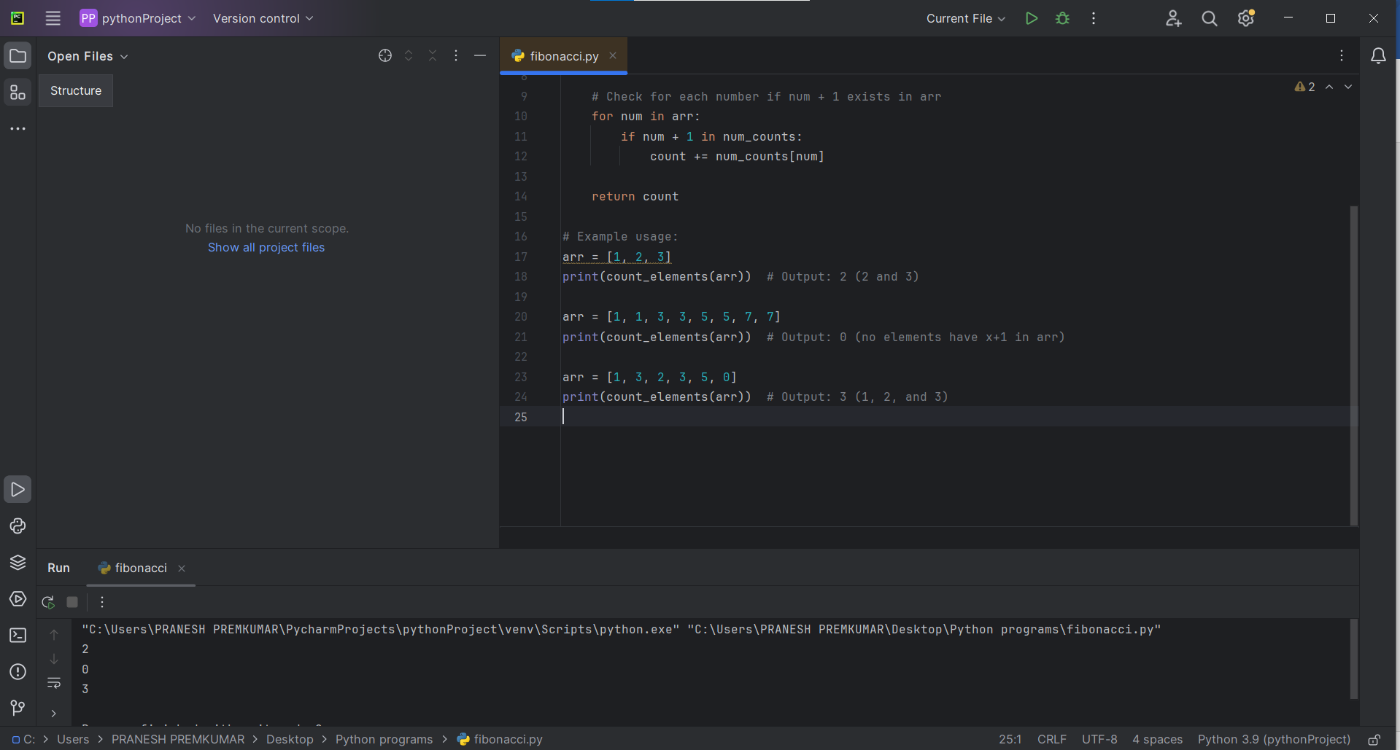

2. Perform String Shifts

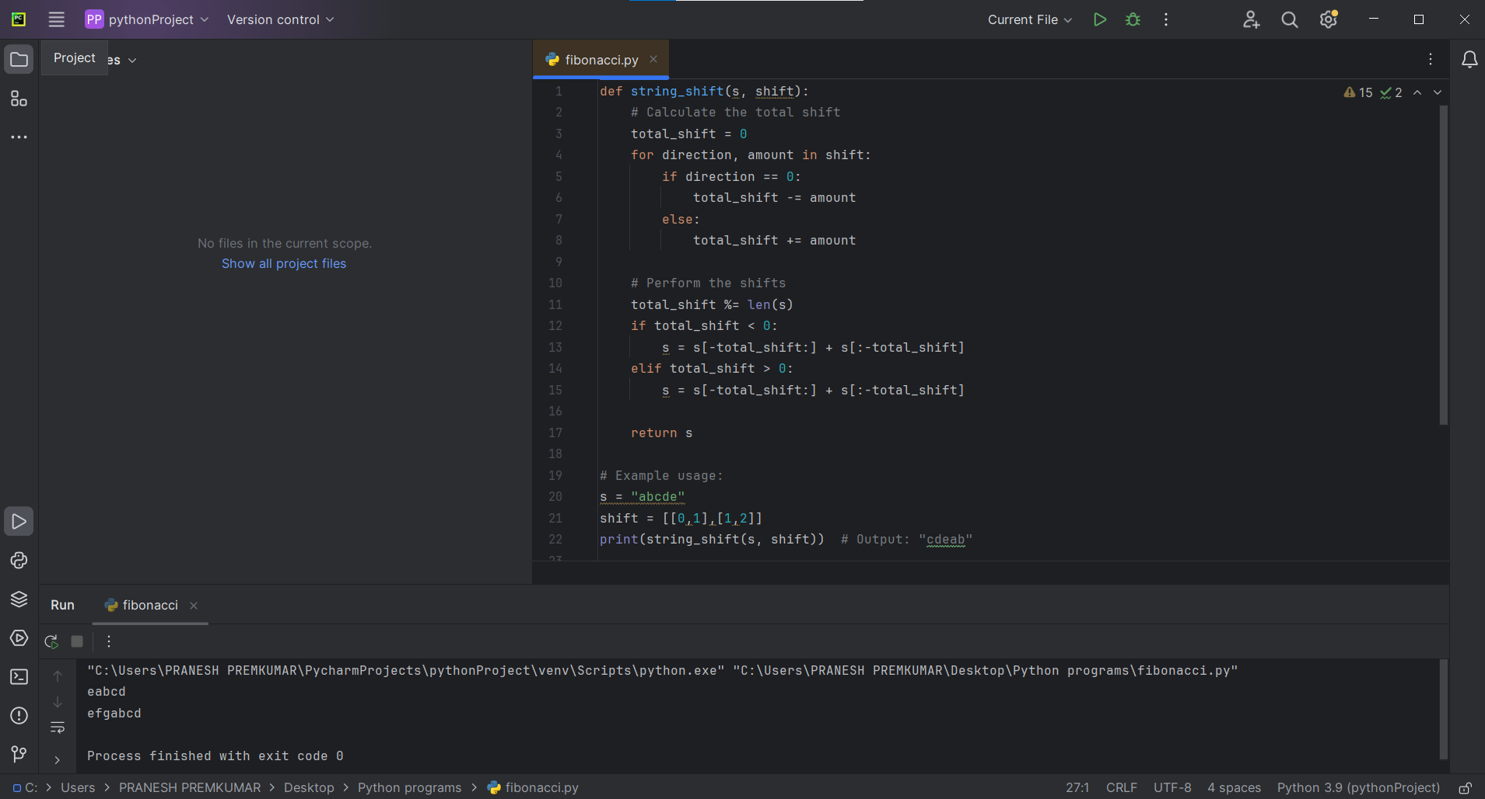

3. Leftmost Column With at Least a One

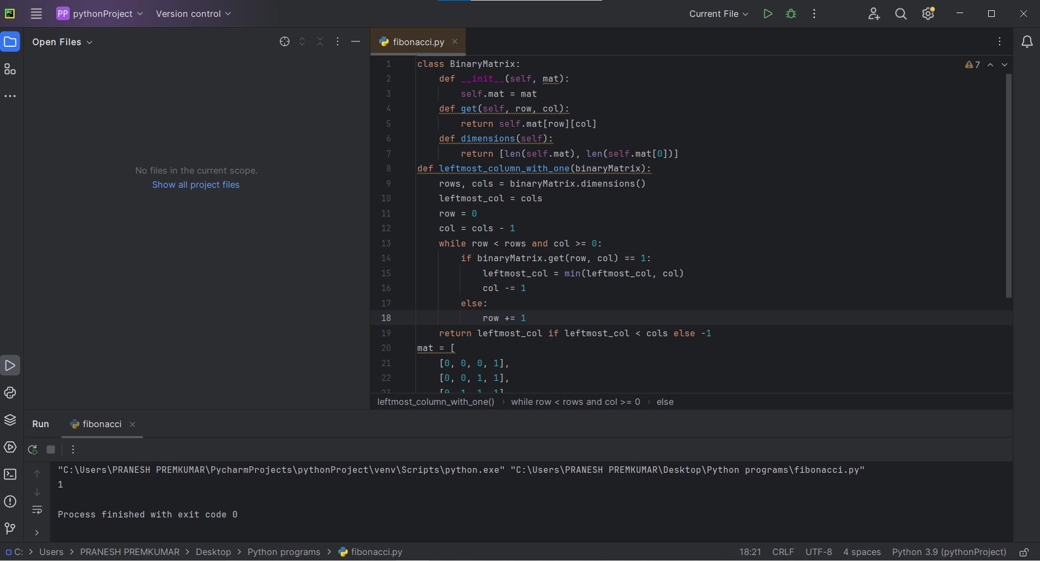

4. First Unique Number

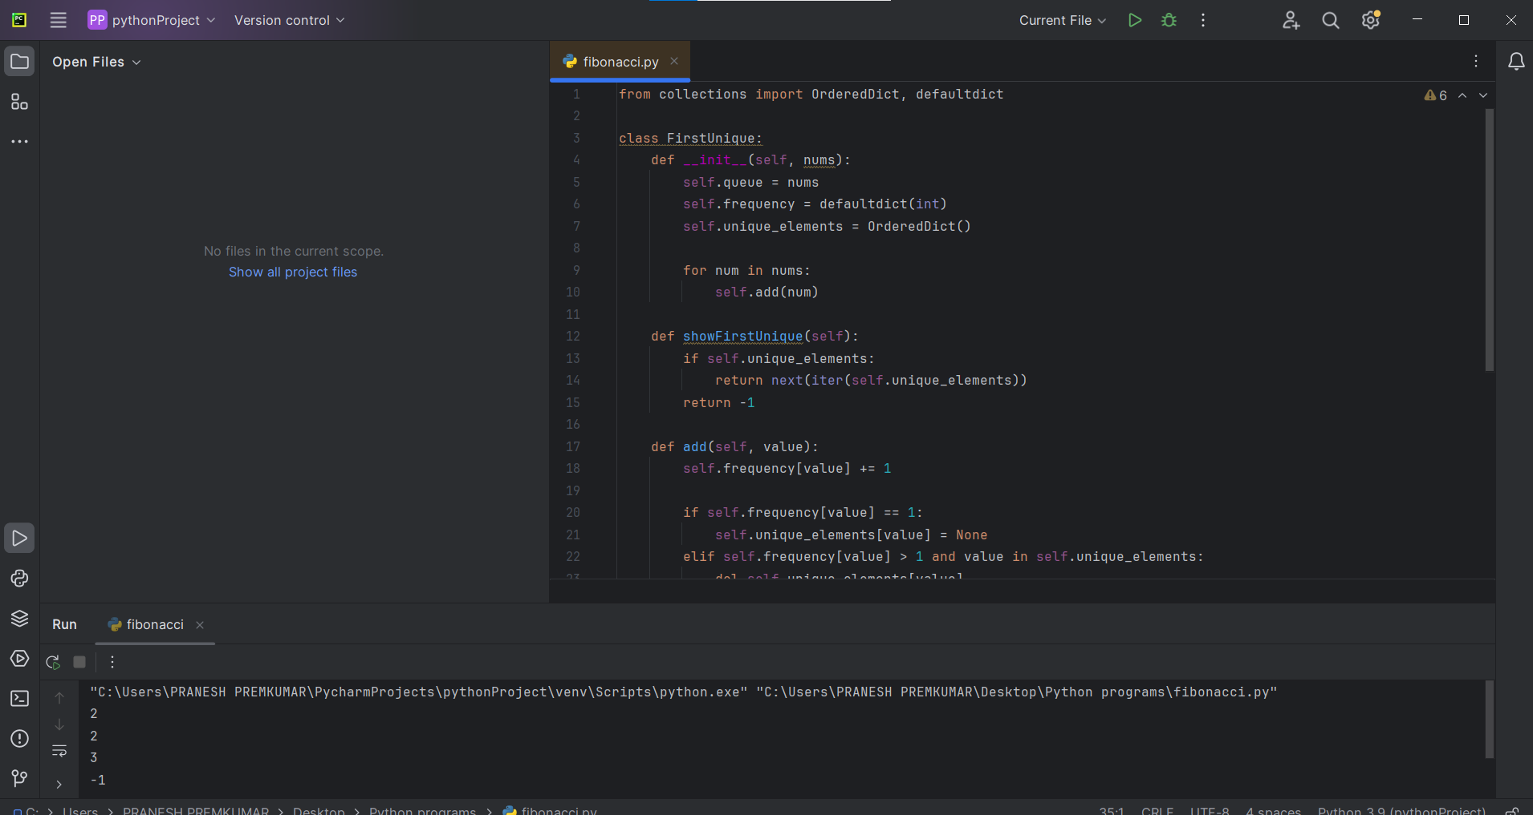

5. Check If a String Is a Valid Sequence from Root to Leaves Path

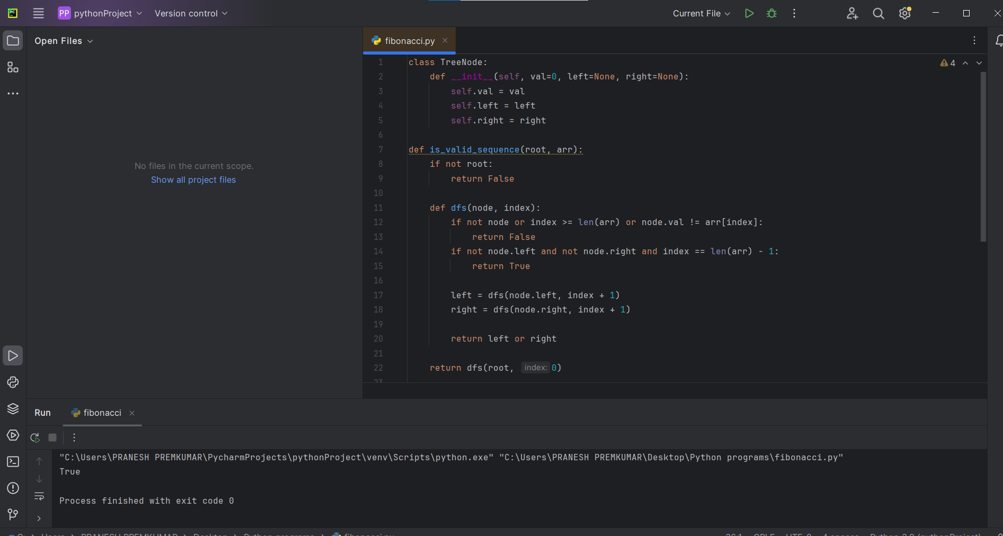

6. Kids With the Greatest Number of Candies

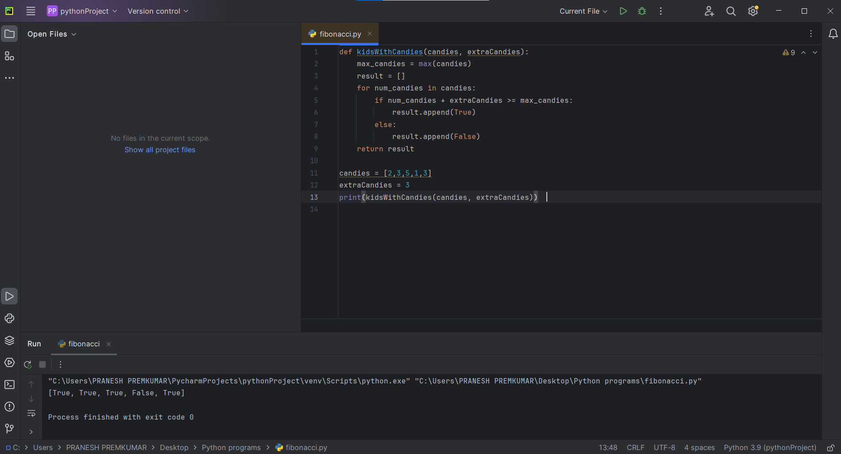

7.Max Difference You Can Get from Changing an Integer

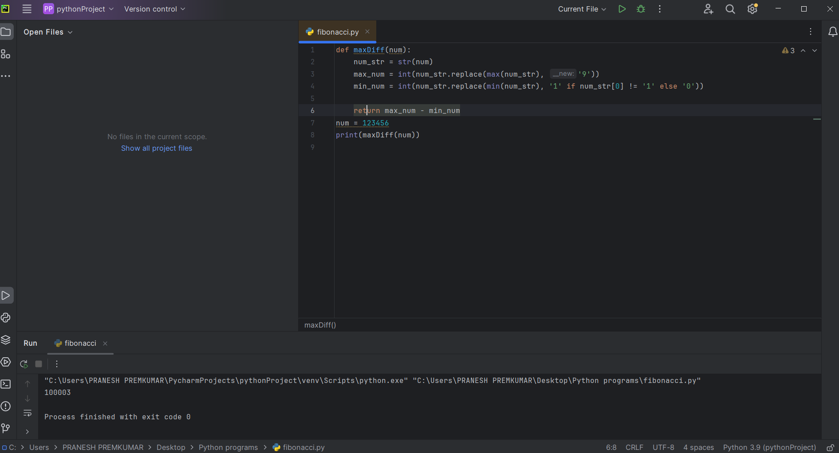

8. Check If a string Can Break Another String 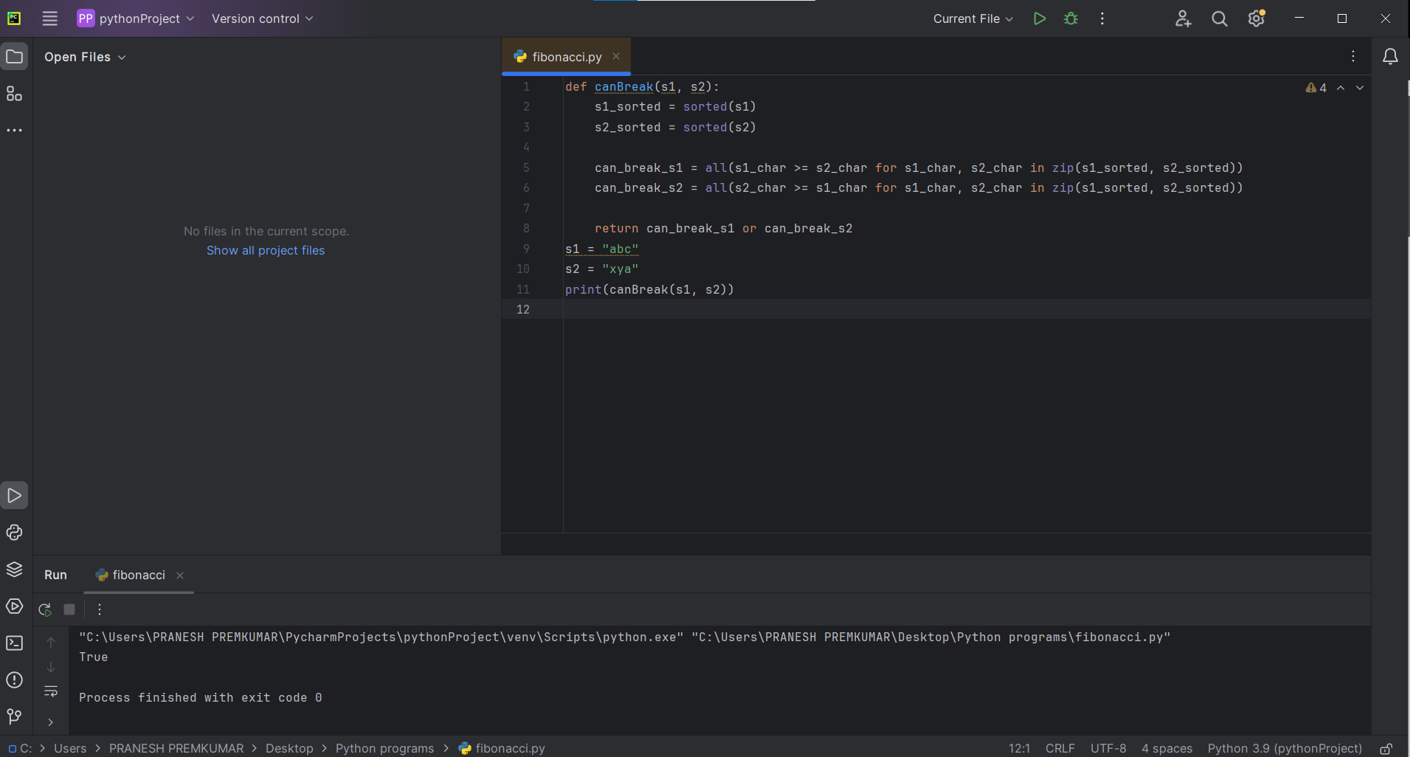

9. Number of Ways to Wear Different Hats To Each Other

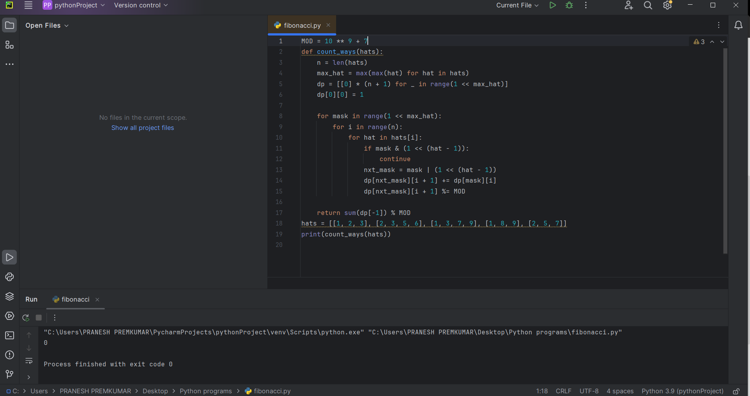

10.Next Permutation

